Installation Instructions
1. For the Kia Sportage, you will need to determine what hublock type you have. The Sportage was produced with two different types of automatic hublocks. For 1995-1997 the Sportage came with a cam type automatic hublock as shown in Figure 1. From 1998 it came with a vacuum type automatic hublock as shown in Figure 2. All other vehicle types, proceed to step 10.
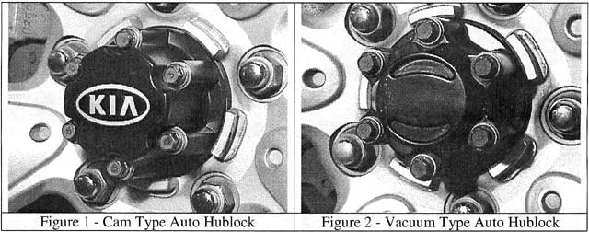
Kia Sportage with the vacuum type hublock, proceed to step 10.
Kia Sportage with cam type auto hublock, proceed to step 2.
All other vehicle types, proceed to step 10.
2. If you have the cam type auto hublock, the front wheels will have to be lifted off the ground.
3. Remove the hublock assembly by removing the six mounting bolts and washers. Do not discard these parts, as they will be required for installing the manual hublock. If your hublock set came with a bolt kit, discard the original bolts as they will be to long.
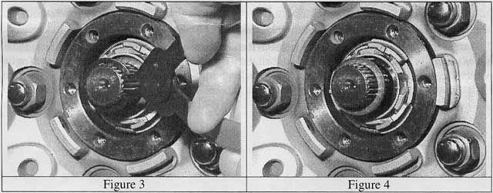

4. Remove the snap-ring, and thrust washer from the axle shaft as shown in Figures 3 and 4.
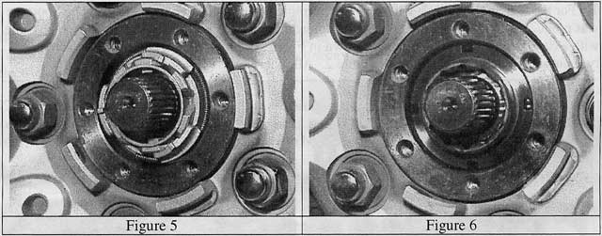
5. Remove the camming assembly, and spindle nut as shown in Figures 5, and 6.
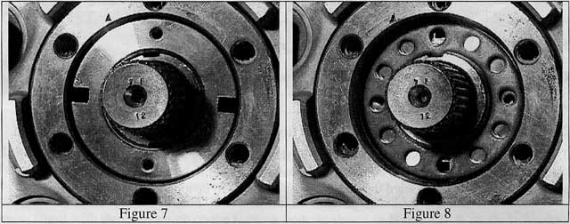
6. Install the new spindle nut, as shown in Figure 7. Rotate the wheel and spindle nut until the spindle nut is finger tight. Torque the spindle nut 4 to 8 kg-cm (3.5-7.0 lb-in).
7. Install the set plate by aligning the holes in the set plate with the threaded holes in the spindk nut as shown in Figure 8. This may require slightly tightening or loosening the spindle nut for proper alignment.
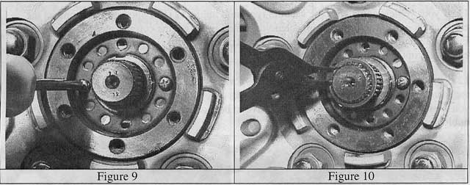
8. Install the set plate screws as shown in Figure 9.
9. Install the axle shaft thrust washer and snap ring as shown in Figure 10. Be sure the snap ring is properly seated in the groove of the axle shaft.
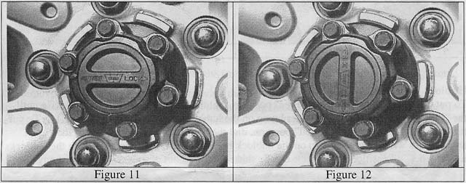
10. Install the manual hublock onto the wheel end. Gently push the hublock into position and align the mounting holes of the hublock with the wheel end as shown in Figure 11. Install the mounting bolts, and lockwashers. Discard the flat washer and use only the lockwasher. If your hublock set came with a bolt kit, use these bolts as the original bolts will be to long. Torque the mounting bolts 3.0 to 3.5 kg-m (21-25 lb-ft).
11. If your vehicle came with the vacuum type auto hublocks (Kia Sportage), disconnect the electrical connector to the vacuum solenoid located in the engine compartment as shown in Figures 13 and 14 below. Cover the end of the connector with electrical tape to prevent electrical contact with other engine components.
12. With the vacuum type auto hublock (Kia Sportage), the original wheel cover will not the manual hublock. Also the wheel cover blocks access to the hublock dial mechanism. you wish to reuse the wheel cover, it will have to be modified with an access hole for the hublock dial mechanism.
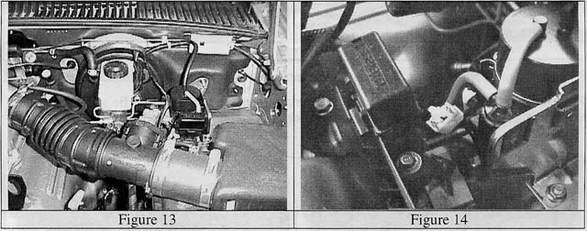

Hublock Function:
To put the hublocks in the 4x2 or "Free" position, dial the hublock dial counter clockwise until the "Free" arrow aligns with the outer bump on the hublock body as shown in Figure 11. To put the hublocks in the 4x4 or "Locked" position, dial the hublock dial clockwise until the "Lock" arrow aligns with the outer bump on the hublock body as shown in Figure 12. With the hublocks in the "Locked" position, the vehicle can be shifted into and out of four wheel drive at any speed.

