Your Searched For:0K0Y2 33 23Z
NiBK not found
Found:PK0051

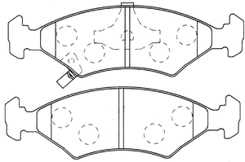 | Description
Length:151.2
Width:46.5
Thicknes:17.9
 | Note:

Your Searched For:PL-0821
Found:PL0821

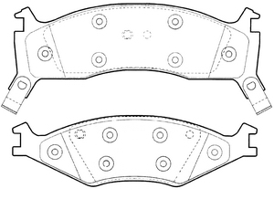 | Description
Length:164.9
Width:49.4
Thicknes:18.0
Length:165.0
Width:62.4
Thicknes:18.0
 | Note:

Your Searched For:FL-11825
Found:FL11825

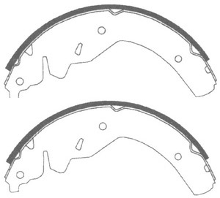 | Description
Length:125.0
Width:57.0
Thicknes:0.0
 | Note:

 | 141270-205

SIZES  165x49.5x18.7  171.5x65.8x16.5 | 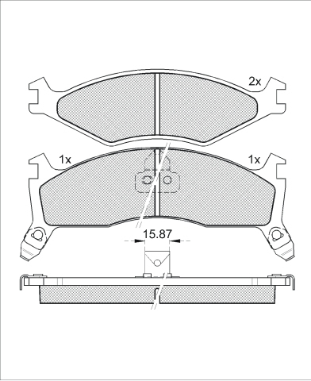
   | 90R-01109/129
  O.E.M | MAKE
  0K011-33-23Z | KIA MOTORS
  0K0Y2-33-23Z | KIA MOTORS
  90R-01109/129
  WVA | FMSI
  21892 | D0670-7550
  21893 | D0719-7550A
  21894
  MAKE
  ASIA MOTORS
  KIA MOTORS

ICER 181231 Sizes 151.5x47.7x17

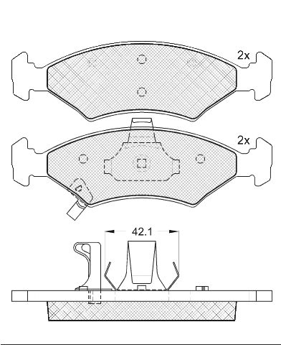
febi-no. 16558

