DIAGNOSIS http://www.sportage-club.com/ipb/index.php?showtopic=3683&hl=%EF%EE%E4%F3%F8%E5%EA&st=0#

1. | Turn ignition switch to ON.

2. | The Air Bag Warning Light should illuminate. If it does not, refer to Air Bag Warning Light service.

3. | The Air Bag Warning Light should go out after approximately 5 seconds. If it stays out, the system is OK.

4. | If the Air Bag Warning Light remains illuminated, there is a problem in the Air Bag-Supplemental Restraint System (SRS).

5. | Turn the ignition switch to LOCK.

6. | Locate the data link connector (DLC) in the left side of the engine compartment and install the Scan Tool.

7. | Turn the ignition switch to ON and record any Air Bag Diagnostic Trouble Codes displayed.

8. | Refer to Air Bag Diagnostic Trouble Code Chart for fault descriptions and actions.  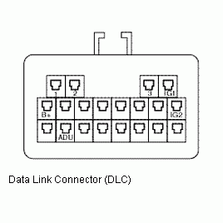
AIR BAG DTC CHART
Air Bag Diagnostic Trouble Code (DTC) Chart
Diagnostic Trouble Code | Faul Description | Possible Cause | Warning Light Code | Air Bag Module Operational | Corrective Action
00 | Crash Occurred | Crash data stored | 1 | All Yes | Replace Air Bag Diagnostic Unit (ADU) and test system
10 | Low Ignition Power Supply | Ignition Power Supply voltage below 9 volts | 3 | All Yes | Repair or replace battery or harness
11 | High Ignition Power Supply | Accessory Power Supply voltage above 16 volts | 3 | All Yes | Repair or replace battery or harness
31 | ADU Fault | Internal fault | 1 | Possible depending on type of fault | Replace Air Bag Diagnostic Unit (ADU)
37 | ADU Incomplete Connection | Connector Fault | 1 | Possible depending on connection terminals | Reconnect ADU connector completely or replace harness
42 | Warning Light Short to Ground | Warning Light damaged, or circuit shorted to ground | - | All Yes | Repair or replace warning light or harness
44 | Warning Light Short to Battery | Warning Light damaged, or circuit shorted to battery | - | All Yes | Repair or replace warning light or harness
57 | Passenger Air Bag Module Short to Ground | Passenger Air Bag module damaged, or shorted to ground | 7 | Passenger : No Steering wheel, knee : Yes | Replace module or harness
58 | Passenger Air Bag Module Short to Battery | Passenger Air Bag module damaged, or circuit shorted to Battery | 7 | Passenger : No Steering wheel, knee : Yes | Replace module or harness
59 | Passenger Air Bag Module Short | Passenger Air Bag module damaged, or open circuit in harness | 7 | Passenger : No Steering wheel, knee : Yes | Replace module or harness
60 | Passenger Air Bag Module Open | Passenger Air Bag module damaged, or open circuit in harness | 7 | Passenger : No Steering wheel, knee : Yes | Replace module or harness
61 | Steering Wheel Air Bag Module Short to Ground | Steering Wheel Air Bag module damaged, or shorted to ground | 6 | Steering wheel : No Passenger, knee : Yes | Replace module or hanress
63 | Steering Wheel Air Bag Module Open | Steering Wheel Air Bag module damaged, or open circuit in harness | 6 | Steering wheel : No Passenger, knee : Yes | Replace module or harness
65 | Steering Wheel Air Bag Module Short | Steering Wheel Air Bag module damaged, or short circuit in harness | 6 | Steering wheel : No Passenger, knee : Yes | Replace module or harness
67 | Steering Wheel Air Bag Module Short to Battery | Steering Wheel Air Bag module damaged, or circuit shorted to battery | 6 | Steering wheel : No Passenger, knee : Yes | Replace module or harness
78 | ADU Inconsistency | ADU unmaches vehicle installed modules | 2 | Possible depending on ADU type | Replace Air Bag Diagnostic Unit (ADU)
91 | Knee Air Bag Module Short to Ground | Knee Air Bag module damaged, or circuit shorted to ground | 8 | Knee : No Steering wheel, Passenger : Yes | Replace module or harness
93 | Knee Air Bag Module Open | Knee Air Bag module damaged, or open circuit in harness | 8 | Knee : No Steering wheel, Passenger : Yes | Replace module or harness
95 | Knee Air Bag Module Short | Knee Air Bag module damaged, or short circuit in harness | 8 | Knee : No Steering wheel, Passenger : Yes | Replace module or harness
97 | Knee Air Bag Module Short to Battery | Knee Air Bag module damaged, or circuit shorted to battery | 8 | Knee : No Steering wheel, Passenger : Yes | Replace module or harness

WARNING LIGHT CODE
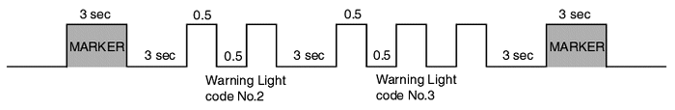
Warning light will be illuminated for remainder, of ignition ON cycle. It spit of being self-corrected the fault, but will not be illuminated after next ignition ON cycle if the fault has erased by Scan Tool.
Air bag diagnostic unitconnector
Terminal | Description | Terminal | Description
1 | - | 12 | -
2 | - | 13 | Passenger air bag module (+)
3 | - | 14 | Air Bag warming light (+)
4 | - | 15 | Driver air bag module (+)
5 | Knee air bag module (+) | 16 | -
6 | - | 17 | -
7 | - | 18 | -
8 | Supply power (IG1) (+) | 19 | -
9 | Communication (K-line) | 20 | Driver air bag module (-)
10 | Knee air bag module (-) | 21 | Ground
11 | - | 22 | Passenger air bag module (-)

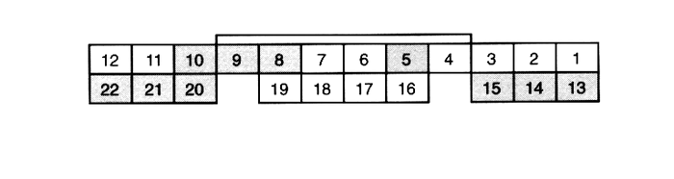
AIR BAG DIAGNOSTIC TROUBLE CODE ERASURE
Disconnecting the Battery will not erase Air Bag Diagnostic Trouble Codes. This procedure can only be performed using the Kia Data Pro-II Tool equipped with the appropriate software.

